**Aim :** Case Study on understand DevOps: Principles, Practices and DevOps Engineer Role and Responsibilities.

**# DevOps**

DevOps is a collaborative approach that bridges the gap between development and operations teams. It emphasizes automation, continuous delivery, and seamless communication. By automating various phases of the software development lifecycle, DevOps improves productivity, consistency, and agility for organizations.

**# Principles of DevOps**

The 7 main Principles of DevOps are:

1. Collaboration:

DevOps emphasizes collaboration between development and operations teams. By working together, they configure software for the operational phase and ensure it meets requirements. Effective information sharing during deployment is crucial for future reference.

1. Customer-Centric Decision Making:

Customer-centric decision-making is a crucial DevOps principle. It involves gathering feedback from existing products to guide future optimization. Live monitoring strategies help address issues, and the fast DevOps lifecycle allows teams to update and improve applications effectively.

1. Making Data Based Decision:

Data-based decision-making in DevOps involves using historical data and team metrics to inform choices related to tech stack selection and tool adoption. Understanding average resolution time helps developers make informed decisions when introducing new tools or procedures. Comparing results against benchmarks guides future improvements.

1. Automation :

The key benefit of DevOps is faster software delivery and patching achieved through automation. Automating all phases—from code reviews to deployment—increases pipeline speed and enhances job satisfaction. Team members can focus on strategic tasks instead of manual work.

1. Regular Improvement:

DevOps emphasizes regular improvement, and Agile methodology focuses on incremental releases. Unlike past strategies that aimed for a perfect product upfront, incremental releases allow teams to deliver a minimum viable product quickly and then add features to enhance value over time.

1. Failure as a learning Opportunity:

Maintaining flexibility in software development involves viewing failure as an opportunity to learn and improve. Encouraging risk-taking allows for growth and success, even when experiments don’t go as planned. This experience informs future strategies and decision-making.

1. Responsibility Throughout the Lifecycle:

 Traditional software development models involved separate development and operations teams. However, DevOps takes a more holistic approach, with the entire team responsible for the product from planning to delivery. Collaboration between development and operations ensures updates and issue resolution throughout the lifecycle.

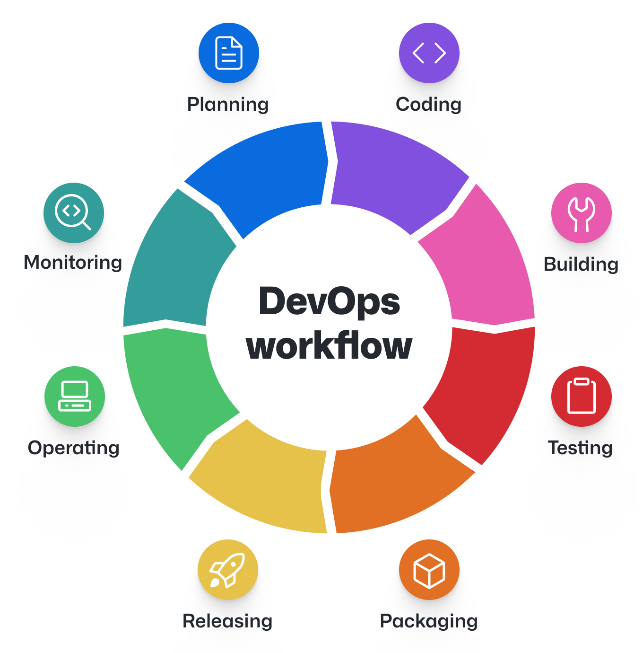

**# DevOps Practices:**

To maximize the benefits of [DevOps principles](https://www.simplilearn.com/devops-principles-to-adopt-article), it's crucial to follow these best practices:

1. Automate Everything

Automate repetitive tasks, including code deployment, testing, and infrastructure provisioning. Automation reduces errors and accelerates the development process.

2. Embrace Continuous Integration (CI)

Implement CI practices to ensure that code changes are continuously integrated into a shared repository, allowing for early detection and resolution of integration issues.

3. Implement Continuous Testing

Integrate automated testing into your pipeline to verify code quality at every stage of development. This ensures that defects are caught early and reduces the risk of issues in production.

4. Use Containers and Orchestration

Containerization technologies like [Docker](https://www.simplilearn.com/tutorials/docker-tutorial/what-is-docker) and container orchestration tools like Kubernetes provide consistency and scalability in deploying applications across different environments.

5. Monitor and Analyze

Implement robust monitoring and analytics tools to gain insights into system performance and user behavior. Proactive monitoring helps detect and address issues before they impact users.

6. Foster a DevOps Culture

Encourage collaboration, communication, and a mindset of continuous improvement throughout your organization. Promote cross-functional teams and shared responsibilities

7. Prioritize Security

Integrate security practices throughout the DevOps pipeline. Conduct regular security assessments and audits to identify vulnerabilities and address them promptly.

8. Document and Share Knowledge

Maintain comprehensive documentation of your infrastructure, processes, and best practices. Sharing knowledge helps onboard new team members and ensures consistency.

9. Measure Key Metrics

Track key performance indicators (KPIs) related to deployment frequency, lead time, and change failure rate. Use these metrics to assess the effectiveness of your DevOps practices continually.

10. Adapt and Evolve

Stay up-to-date with industry trends and emerging technologies. Be prepared to adapt and evolve your DevOps practices to meet changing business needs.

**# The role of DevOps Engineer**

DevOps Engineerplays a crucial role in bridging the gap between development and operations teams to streamline and automate the processes involved in the software development lifecycle. Here are the key roles and responsibilities of a DevOps Engineer.

1. Infrastructure Automation: DevOps engineers create and manage infrastructure as code (IaC) using tools like Terraform, Ansible, or CloudFormation. They automate server provisioning, configuration, and scaling.
2. Continuous Integration and Deployment (CI/CD): DevOps engineers design and maintain CI/CD pipelines. They ensure seamless code integration, automated testing, and efficient deployment to production environments.
3. Monitoring and Alerting: DevOps engineers set up monitoring tools (e.g., Prometheus, Grafana) to track system performance, detect anomalies, and respond to incidents promptly. They configure alerts for critical events.
4. Containerization and Orchestration: DevOps engineers work with Docker and Kubernetes to containerize applications and manage container orchestration. They optimize resource utilization and ensure high availability.
5. Security and Compliance: DevOps engineers embed security practices into the development process. They address vulnerabilities, manage access controls, and enforce compliance with industry standards.
6. Collaboration and Communication: DevOps engineers bridge the gap between development and operations teams. Effective communication, collaboration, and knowledge sharing are essential aspects of their role.
7. Release Management: DevOps engineers coordinate software releases, ensuring smooth transitions between development, testing, and production environments. They manage version control and rollback strategies.
8. Performance Optimization: DevOps engineers analyze system performance, identify bottlenecks, and optimize resource usage. They fine-tune databases, web servers, and application stacks.
9. Disaster Recovery and Backup: DevOps engineers plan and implement disaster recovery strategies. They set up backup systems, perform regular backups, and test recovery procedures.
10. Capacity Planning and Scalability: DevOps engineers assess resource requirements, plan for growth, and scale systems horizontally or vertically. They monitor capacity utilization and adjust infrastructure as needed.

**# Responsibilities of DevOps Engineer**

The responsibilities of a DevOps engineer are diverse and crucial for successful software development and operations. Here are some key tasks they handle:

1. Infrastructure Automation: DevOps engineers create and manage infrastructure using code (IaC). They automate server provisioning, configuration, and scaling.
2. CI/CD Pipeline Management: They design, maintain, and optimize continuous integration and deployment pipelines. This ensures efficient code integration, testing, and deployment.
3. Monitoring and Alerting: DevOps engineers set up monitoring tools to track system performance, detect anomalies, and respond to incidents promptly.
4. Containerization and Orchestration: They work with Docker and Kubernetes to containerize applications and manage orchestration. This enhances scalability and resource utilization.
5. Security Integration: DevOps engineers embed security practices into the development process. They address vulnerabilities, manage access controls, and ensure compliance.
6. Collaboration and Communication: Bridging the gap between development and operations, they facilitate effective communication and knowledge sharing.
7. Release Management: Coordinating software releases, they manage version control, rollback strategies, and smooth transitions between environments.
8. Performance Optimization: DevOps engineers analyze system performance, identify bottlenecks, and optimize resource usage.
9. Disaster Recovery Planning: They plan and implement disaster recovery strategies, set up backups, and test recovery procedures.
10. Capacity Planning and Scalability: Assessing resource requirements, they plan for growth and scale systems as needed.

**Conclusion:**

The case study of DevOps is completed successfully